Walk in My Shoes: The Path to Empathy and Compassion
by Cliff Hakim

Book Excerpt 1: Walk Storyteller

Walk with an Open Spirit
Suzanna Perot
Artist and Professional Organizer
My interview with Suzanna Perot was conducted over the telephone. We had never met, yet I was immediately affected by her soft, deliberate voice and a life threaded with hope and curiosity.
I was astonished by her empathy for veterans and her deep understanding of the chasm between men who go to war and the domestic life they are expected to return to—though their souls have been shattered and their lives forever changed.
When I asked, “What does it feel like to walk in your shoes? And can you tell me about your favorite pair?” She said, “I have a favorite pair of red shoes called Agapes, which in Greek means love for humanity. When I have those shoes on, I feel radiant and joyful to be alive. This kind of brightness is energetic and comes from the inside.”
I felt connected to Suzanna as she described her compassion for the combat vets she encountered at an early age. When we finished talking, I needed time to wipe my tears and compose myself.

Agape
Suzanna’s shoes are artisan-tooled and richly textured like her spirit and her journey.
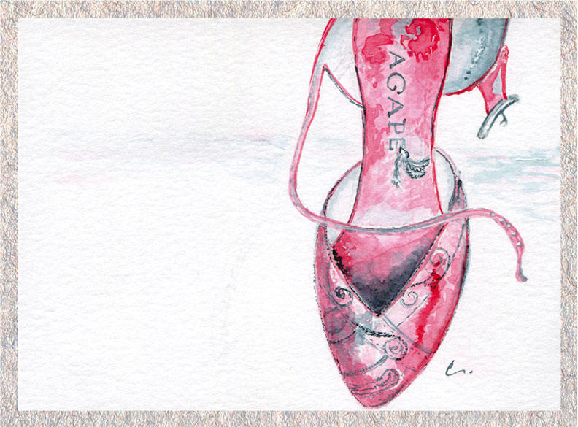

Suzanna’s Walk
I’ve illustrated a book, taught classes in soul collage, and designed jewelry and stained-glass windows. I’ve made gardens, upholstered furniture, and fashioned custom shoes—one for a ballerina who was married on the beach. Another for a woman who wanted to turn a pair of running shoes into formal wear. I covered them with crystals and laced them up with silk ribbons! My client said, “It was like having diamonds on the soles of my shoes.”
When I was younger, I took a modeling class and learned that people glance at your face and then at your shoes—they do this unconsciously. Throughout history, shoes have been a status symbol; you could tell what walk of life a person was in by the shoes they wore and by their condition.
My mother was a fashion model in New York City during the 1940s. Modeling is about being centered and radiant. Beauty is who you are—from the inside out. My father worked for JCPenney managing the shoe department. He would bring home sample high heels in size 5 ½, and wouldn’t you know it, those shoes fit. At five-foot-two, I felt tall in those shoes. I learned from my mom how to wear heels gracefully. She would put a book on my head and say, “Take a stride, but keep that book stationary.” The movement, I learned, was in my hips, and the goal was keeping my back straight while I walked. Sometimes, I’d imagine carrying a cup of hot coffee and not spilling a drop.
Right now, I am thinking about a pair of metallic-copper high heels given to me by a former boyfriend. They were a beautiful, well-made Italian pair. They embodied how I felt in that relationship—graceful, seen, and valued.
But there’s another memory that comes up too. I had just turned eighteen, and I was living with my older sister in Denver. At the time I was working in a department store and earning very little money. On Friday when we got paid, I would buy myself the most frugal lunch—a hot dog covered in mustard and relish and a hot cup of tea with sugar. As I sat down to eat, I glanced out the window and saw a young man around my age. His legs were stumps, and he was shivering from the cold. I could not take my eyes off him. I fought back my tears, then wrapped up my lunch, hot dog and tea, walked out and gave it to him. But as soon as I turned away, I started to cry. He was so young and handsome, a Vietnam veteran. That war was so unpopular, and many were destroyed by it. I think about him often and wonder if he is still alive. Memories like this never go away.
About the same time, I met a young soldier who was just coming back from the war. He wanted me to stay overnight with him. He said, “I promise I won’t touch you. I just want to be in the same room with you.” I said yes. After I got under the covers with my clothes on, he sat on the bed across from me, as if he were on guard, the entire night. The next morning, at the bus station, he wrapped his arms around me and said, “Thank you. This makes it easier for me to go home.”
It’s hard for women to walk in the shoes of these young men. They’re worried about the wedding plans and their china patterns. But these men have been radically changed, and we just can’t imagine what they’ve gone through. The suicide rates for returning vets are very high. We are so helpless to protect them. There’s nothing worse than being a new bride, then having your husband sent off to be dehumanized in basic training, and then off to a war nobody wins.
At twenty, I joined my new husband in Korea on a tourist visa, as “unauthorized personnel.” The Army said, “If we had wanted your husband to have a wife, we would have issued him one.” I went there on my own dollar, out of sheer defiance.
When the guys would go out on surveys, they’d come by the village first to pick me up. I had a fatigue jacket, and they got me a pair of size six men’s combat boots, and we’d take off into the rice paddies. I drank with them, sang with them, and got to know these soldiers in a way no other woman did. They were only teenagers. They were there because they were drafted.
When my husband came home from Korea, I planted flowers in his combat boots and set them out on the front doorstep.
My father was in the Air Force and on the front lines when his older brother was killed in WWII. When we were little, we slept in Army cots, then Army bunk beds carved with the letters “U.S.” And I thought that meant US! We were raised in military fashion—a bed made so you could bounce a quarter off it, shoes spit-polished, stand tall, yes sir/no sir “basic training.”
When you have a lineage of war in your family, it’s in your genes. “Self-compassion begets compassion for all humankind,” I hear my grandmother whisper to me when I struggle. “You cannot judge another unless you walk a mile in their moccasins.” She would know. Half of her genes were Native American.

